 **Chinook Pass Cabin Owners Association**

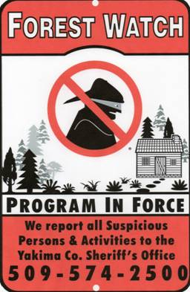

**Forest Watch Program: Incident Reporting Sheet**

***Observe and Report!!!***

**Know who your cabin neighbors are and know what vehicles are normally present and report suspicious, vehicles, individuals, and activities**

**The following are key items observe, remember and REPORT if you witness some unusual or suspicious activity.**

***Date: _____________ Time: ____________***

***Describe the Person/Persons:***

How Many people? Shirt/Jacket Color

Sex: Pants Color

Hat/Hair Color Shoe Type/Color

Face Shape Other distinguishing features

Eye Color

***Describe the Vehicle:***

Color of Vehicle Number of doors

Make License Plate No.

Model

***Describe the event***

Damage What did you see?

Stolen items

**Reporting Phone Numbers:**

***EMS - 911***

***Yakima County Sheriff’s Office - (509) 574-2500,***

***Washington State Patrol - (509) 575-2320***

***Naches Ranger Station – (509) 653-1400***

***Fire – Central WA Interagency Communication Center – (509) 826-3383***

***Northwest Avalanche Center – (800) 526-6677***

***Tract Location Description:***

***{Sponsor to provide Tract Specific information}***