 **Chinook Pass Cabin Owners Association**

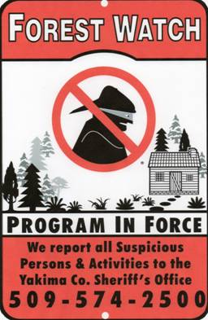

{Date}

Dear Fellow Cabin Owners:

The {cabin tract name} tract is in the process of joining the CPCOA Forest Watch Program, and {I/we} will be acting as the sponsor.

As you know, cabin break-ins have been and continue to be a problem for our tract. While we all know that there is no “silver bullet” solution to this problem, CPCOA has developed the “Forest Watch” program to reduce the number and magnitude of break-ins.

The Forest Watch program is modeled after the very successful Neighborhood Watch programs which have been implemented nationwide.  The basic premise is that “*WE LOOK OUT FOR EACH OTHER*”.  The simple idea is that if we are all watching out for suspicious activities and report them that the individuals in question will choose to leave our cabins alone.

Our role is ONLY to Observe and Report ***not to intervene***.  If we all are looking out for each other and we can recognize who should and shouldn’t be in and around our cabins we should be able to reduce the amount and severity of the crime that occurs in and around our cabins.

The CPCOA Forest Watch Program is comprised of a number of things: signs, information sheets, contact lists and Operation ID. But it’s our ability to *observe, report and communicate* between ourselves that will make a difference. Your participation in this effort is essential!

Reach out and get to know your neighbors and be aware of the vehicles that are normally present within your tract. If you observe any suspicious individuals, vehicles and/or activities or discover a break-in, please report this to the Yakima County Sheriff’s Office as soon as possible.

***Together we can make a difference!***

{remove the following paragraph if you are not installing a sign at the tract entrance}

**SIGNS**

Shortly you will notice a Forest Watch sign at the entrance to our tract. This informs potential thieves that we have organized and are watching out for each other. You may see these signs at other cabin tracts in the area, but probably not at all since this is an optional program and some tracts have opted to avoid the signs altogether.

[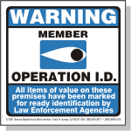](http://www.nnwi.org/ioil3.asp)**Operation ID**

Operation ID has been implemented in various communities nationwide with success. It’s comprised of 3 parts: marking valuables, list valuables and post notices.

1. **Mark Valuables.**  All portable valuable property (electronics, tools, generators, chain saws, etc.) should be properly marked in some indelible manner (engraving, permanent paint) with the property owners Washington State Driver’s License Number (for example – “*WSDL# SMITHME502CZ”*). By proving this information any law enforcement agency will be able to properly and rapidly locate that rightful property owner. It also does have some deterrent value.
2. **List Valuables.** It is also a good idea for cabin owners to keep a current inventory/listing of valuable property that is in their cabins at a separate location. In the event of a break-in the owner can adequately describe any stolen property to the Yakima Co. Sheriff’s office. It will also help with any insurance claim that they may wish to file. An excellent way to do this inventory is to take photos of the valuable items and add any unique information (serial numbers, model number/year, estimated value) on a sheet. A form has been included with this packet. An electronic version of this form is available on the CPCOA website.
3. **Window Stickers.** Included in this packet is a couple of small window stickers for each cabin in the tract that inform anyone considering breaking in that the property has been marked and will be traceable as stolen property. Additional stickers can be provided as needed.

You should also find enclosed in this packet the following information concerning the program:

* **Tract Contact Sheet.**  This sheet contains the most current information that is available on each cabin owner’s contact information, including home address, telephone numbers and email addresses. The purpose of this sheet is to enable cabin owners to communicate with one another should the need arise. Please review your information on this sheet and let {me/us} know of any errors or omissions.
* **Incident reporting Sheet.** This sheet contains the key phone numbers to call should you experience a break-in or observe some suspicious activity around our tract. It also lists the most common information request that law enforcement makes.

Don’t hesitate to contact {me/us} should you have any questions about this program.

Sincerely,

{name(s)}

{cabin #}

{Contact Information}